Experiment No: 01

Experiment Name: Study of Language Processing Phases and Use of Makefile

Theory
A language processing system is a collection of programs that processes a source program and converts it into a form that can be executed by a computer. In the case of a C program, the source code is not directly executed by the computer. It passes through several processing stages before an executable file is produced. The main phases are preprocessing, compilation, assembly, and linking.
1. Preprocessing: The preprocessing phase is the first phase of the language processing system. The preprocessor processes the C source file before actual compilation begins. It handles preprocessing directives such as #include, #define, and conditional compilation directives. For example: #define PI 3.1416 , The preprocessor replaces the macro PI with its defined value. The .i file contains the source code after preprocessing. The command used in this experiment is: gcc -E asif_032.c -o asif_032.i and produces the preprocessed file: asif_032.i

2. Compilation: The compilation phase takes the preprocessed source code as input and translates it into assembly language. The compiler analyzes the source code and generates instructions that are closer to the machine's instruction set. For example, after preprocessing, the compiler receives the contents of asif_032.i. It then translates the C statements into corresponding assembly instructions. The command used in our experiment is: gcc -S asif_032.i -o asif_032.s

3. Assembly: The assembly phase converts the assembly language program into machine-level object code. The assembly file generated in the previous phase is given to an assembler. oThe .o file is an object file containing machine code, but it is not yet a complete executable program. In our experiment, the following command is used: gcc -c asif_032.s -o asif_032.

4. Linking: The linking phase is the final phase in this language processing process. In this phase, the linker combines the object code with the required library code and other necessary components to create the final executable program. For example, the printf() function used in our C program belongs to the standard C library. The linker makes sure that the required library components are properly connected with the object code. Therefore, the linking phase completes the conversion of the source program into an executable program.

Language Processing Flow
The complete processing sequence in this experiment is:
asif_032.c
|
| Preprocessing
↓
asif_032.i
|
| Compilation
↓
asif_032.s
|
| Assembly
↓
asif_032.o
|
| Linking
↓
asif_032.exe

Makefile
A Makefile is a special configuration file used with the make utility to automate the process of building and compiling a program. It contains a set of rules and commands that tell the system how to create the required output files from the source files. In a language processing system, a Makefile can be used to automate the different compilation stages instead of entering each command manually. For a C program, a Makefile can define rules for generating the preprocessed file, assembly file, object file, and executable file.
For example: Instead of typing these commands one by one every time, they can be written inside a Makefile:
first:
gcc -E asif_032.c -o asif_032.i
gcc -S asif_032.i -o asif_032.s
gcc -c asif_032.s -o asif_032.o
gcc asif_032.o -o asif_032.exe
Then, the compilation process can be started using: make
The main purposes of a Makefile are:
- Automate compilation: It allows multiple compilation commands to be executed automatically.
- Reduce manual work: The programmer does not need to type every command repeatedly.
- Maintain the correct order: It can ensure that different processing stages are performed in the required sequence.
- Manage dependencies: It can specify which output files depend on which source files.
- Save time: When a project contains many source files, only the necessary parts can be rebuilt.
- Organize the build process: All compilation and build instructions can be kept in one file.
Code
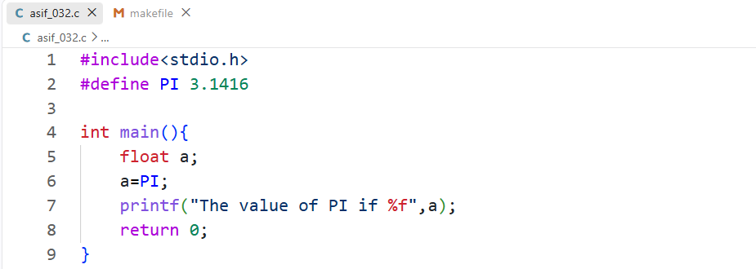
Input:
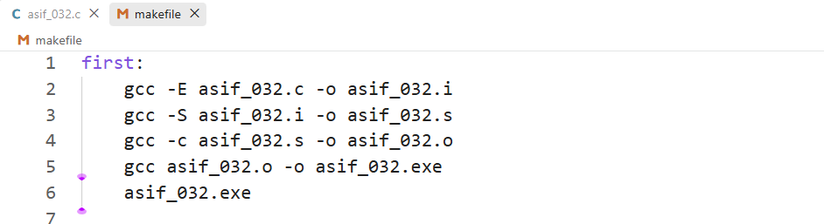
Output:
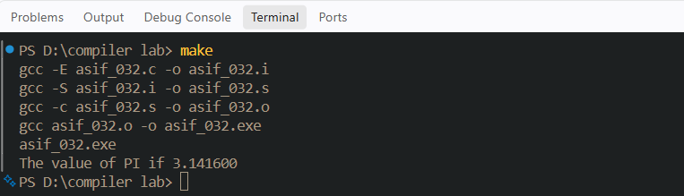
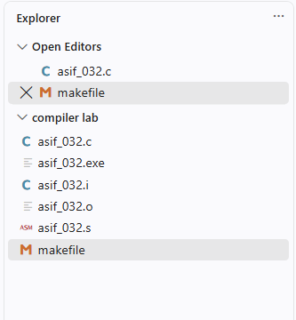

Discussion
In this experiment, I studied the different phases of a language processing system and observed how a C source program is converted into an executable program. First, I wrote the C source code in the file asif_032.c and used the GCC preprocessor to generate the preprocessed file asif_032.i. In this stage, preprocessing directives such as #include and #define were processed. Next, I used the compiler to convert the preprocessed code into assembly language, which generated the asif_032.s file. After that, the assembler converted the assembly code into machine-level object code and produced the asif_032.o file. Finally, the linker combined the object code with the required library components and generated the executable file asif_032.exe, which was then executed to obtain the expected output. Through this experiment, I clearly understood that a C program does not directly become an executable file; instead, it passes through several processing stages, and each stage produces a specific intermediate file. I also learned the importance of a Makefile, which can automate these compilation steps and reduce the need to enter multiple commands manually. Overall, this experiment helped me understand the practical working process of language processing and the transformation of source code into an executable program.

Experiment No: 02

Experiment Name: Design and Implementation of a Lexical Analyzer Using Flex

Theory
Lexical analysis is the first phase of the compiler in which the source program is read character by character and grouped into meaningful units called tokens. These tokens may include keywords, identifiers, integers, floating-point numbers, operators, and other symbols. The main purpose of lexical analysis is to identify the different types of lexemes in the source program and provide tokens for the next phase of the compiler.
A lexical analyzer is the component of a compiler that performs lexical analysis. It takes the source code as input, recognizes lexemes according to predefined patterns, and produces the corresponding tokens as output. In this experiment, Flex is used to generate the lexical analyzer using regular expressions and rules.

1. Lexeme: A lexeme is the actual sequence of characters in the source program that matches a particular pattern and represents a meaningful unit. For example, in the statement int total = 25;, int, total, and 25 are lexemes.

2. Token: A token is the category or classification assigned to a lexeme by the lexical analyzer.

Thus, the lexeme is the actual text, while the token represents its type. For example:
int → Keyword
total → Identifier
25 → Integer

3. Pattern: A pattern is a rule that describes the form of a lexeme. In lexical analysis, regular expressions are commonly used to define these patterns. For example: [0-9]+ is a pattern for recognizing integers, while: [a-zA-Z_][a-zA-Z0-9_]* is a pattern for recognizing identifiers.

Regular Expressions
A regular expression (RE) is a formal notation used to describe a specific pattern or set of strings. In a compiler, regular expressions are mainly used during the lexical analysis phase to define the structure of different types of tokens in a source program. A lexical analyzer uses these patterns to identify and classify elements such as keywords, identifiers, constants, numbers, operators, and special symbols. For example, the regular expression [A-Za-z][A-Za-z0-9]* can be used to define an identifier, where the first character must be a letter and the remaining characters can be letters or digits. Similarly, [0-9]+ represents an integer number consisting of one or more digits. Regular expressions use operators such as union (|), concatenation, and repetition (*) to create more complex patterns. By defining tokens with regular expressions, the lexical analyzer can scan the source code efficiently, recognize valid tokens, and separate them from unnecessary characters such as spaces and comments. Therefore, regular expressions provide a simple and systematic method for specifying lexical patterns and helping the compiler recognize tokens correctly.
Regular expressions are used in lexical analysis to define the patterns of different lexemes that appear in a source program. A lexical analyzer compares each sequence of characters in the program with these predefined patterns and identifies the corresponding token. For example, keywords such as if, while, int, and return can be represented by specific patterns or listed as reserved words. An identifier can be defined by the regular expression [A-Za-z][A-Za-z0-9]*, which means it must start with a letter and may be followed by letters or digits. An integer can be represented by [0-9]+, which accepts one or more digits such as 10, 25, or 100. A floating-point number can be defined using a pattern such as [0-9]+\.[0-9]+, which matches numbers like 3.14, 10.5, and 25.75. Therefore, regular expressions provide a systematic way for the lexical analyzer to recognize different lexemes and classify them into appropriate token types during the lexical analysis phase of a compiler.

Flex
Flex (Fast Lexical Analyzer Generator) is a tool used to automatically generate a lexical analyzer from a set of regular expressions and corresponding actions. It is commonly used in compiler design to make the process of lexical analysis easier and faster. In Flex, the programmer defines different lexical patterns for tokens such as keywords, identifiers, integers, operators, and symbols using regular expressions. Flex reads these rules and generates a C program, usually called lex.yy.c, which works as a lexical analyzer. The generated analyzer scans the source code character by character, matches the input with the specified patterns, and produces the appropriate tokens. For example, a Flex rule can recognize [0-9]+ as an integer or [A-Za-z][A-Za-z0-9]* as an identifier. Therefore, Flex reduces the amount of manual coding required to build a lexical analyzer and provides an efficient and systematic way to recognize tokens during the lexical analysis phase of a compiler.

Basic Structure of a Flex (.l) File
A Flex (.l) file is used to define the rules and actions for generating a lexical analyzer. It mainly consists of three sections: Definitions, Rules, and User Code. These sections are separated by a line containing %%. The Definitions section is the first part of the file and contains declarations, header files, macros, and other definitions that are required by the lexical analyzer. The Rules section is the main part of the Flex file, where regular expressions and their corresponding actions are written. When the input matches a particular pattern, Flex performs the specified action, such as printing a message or returning a token. The User Code section contains additional C code, such as the main() function and supporting functions, which are included in the generated lexical analyzer. The basic structure can be represented as:
Definitions
%%
Rules
%%
User Code
Thus, a Flex .l file provides a clear and organized way to define token patterns, specify actions for matched lexemes.

Code
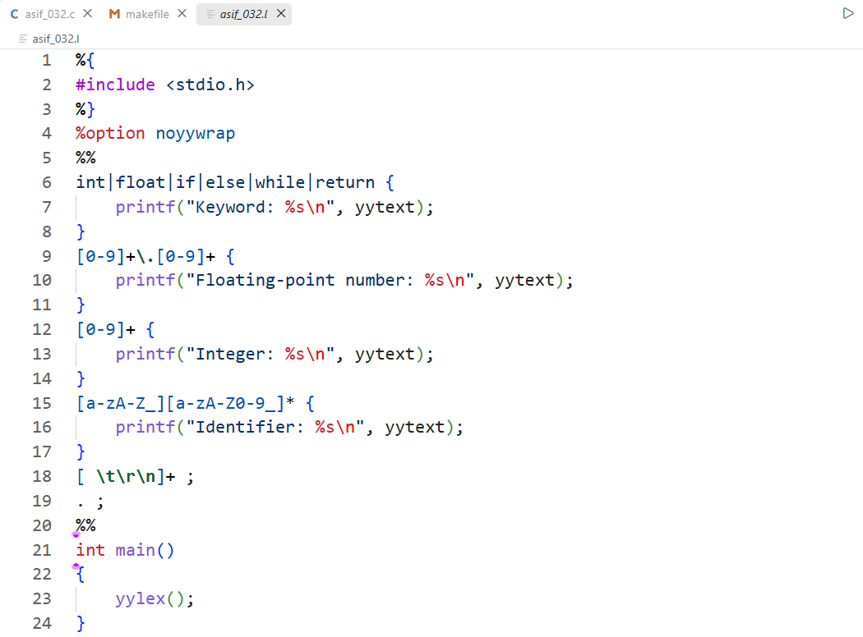

Input & Output
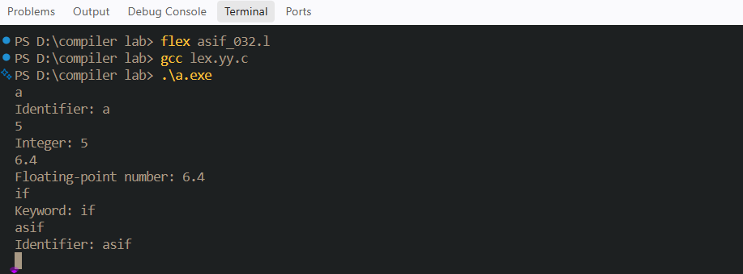
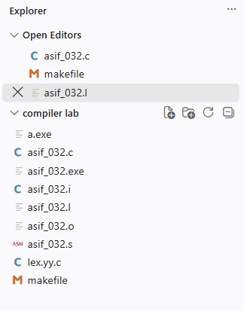

Discussion
In this experiment 2, I implemented a lexical analyzer using Flex. First, I created a Flex source file containing regular expressions and their corresponding actions. The rules were designed to identify keywords, identifiers, integers, and floating-point numbers.I tested the lexical analyzer using a sample input containing different types of tokens. When the program encountered a keyword such as int, float, if, else, while, or return, it displayed it as a keyword. Similarly, variable names were recognized as identifiers, whole numbers were recognized as integers, and numbers containing a decimal point were recognized as floating-point numbers.The program also contains an Unknown rule for characters that do not match the specified token patterns. For example, operators such as = and > are displayed as Unknown because specific rules for operators were not included in the given Flex program.During the experiment, I learned how regular expressions can be used to describe lexical patterns and how Flex uses those patterns to generate a lexical analyzer. This experiment helped me understand the role of lexical analysis as an important stage of compiler design.

Conclusion
Through these two experiments, I gained a basic understanding of language processing and lexical analysis. In Experiment 01, I learned how a C program passes through preprocessing, compilation, assembly, and linking stages to produce an executable program. I also understood the purpose of intermediate files such as .i, .s, and .o.
In Experiment 02, I learned how a lexical analyzer identifies different types of tokens using regular expressions and Flex. I successfully defined patterns for keywords, identifiers, integers, and floating-point numbers. Overall, these experiments provided a practical understanding of important concepts used in compiler design.

